Actividad 2

# ---- Paquetes necesarios ----  
if(!require("readxl")){install.packages("readxl")}

Cargando paquete requerido: readxl

if(!require("pwr")){install.packages("pwr")}

Cargando paquete requerido: pwr

Warning: package 'pwr' was built under R version 4.4.3

if(!require("car")){install.packages("car")}

Cargando paquete requerido: car

Cargando paquete requerido: carData

if(!require("MASS")){install.packages("MASS")}

Cargando paquete requerido: MASS

Warning: package 'MASS' was built under R version 4.4.3

library(readxl)  
library(pwr)  
library(car)  
library(MASS)  
  
# ---- Importar y explorar datos ----  
# Carga de datos desde Excel  
insectos = read_xlsx("C:/Users/dvalh/Desktop/UA/MatesUA/Prácticas de empresa + privado/Actividades 1 a 3/Actividad 2/capturas_insectos_.xlsx")  
summary(insectos) # Visualización básica de los datos

Tratamiento Replica Conteo   
 Length:40 Min. : 1.0 Min. : 0.00   
 Class :character 1st Qu.: 3.0 1st Qu.: 11.75   
 Mode :character Median : 5.5 Median : 26.50   
 Mean : 5.5 Mean : 44.70   
 3rd Qu.: 8.0 3rd Qu.: 55.25   
 Max. :10.0 Max. :292.00

# ---- Cálculo del tamaño muestral para ANOVA ----  
pwr.anova.test(k = 4, n = NULL, f = 0.4, sig.level = 0.05, power = 0.8)

Balanced one-way analysis of variance power calculation   
  
 k = 4  
 n = 18.04262  
 f = 0.4  
 sig.level = 0.05  
 power = 0.8  
  
NOTE: n is number in each group

# Estima que n ≈ 15 por grupo sería suficiente  
  
# ---- ANOVA tradicional ----  
insectos$Tratamiento = as.factor(insectos$Tratamiento)  
modelo_aovtr = aov(Conteo ~ Tratamiento, data = insectos)  
summary(modelo_aovtr)

Df Sum Sq Mean Sq F value Pr(>F)  
Tratamiento 3 18256 6085 2.199 0.105  
Residuals 36 99609 2767

# ---- Diagnóstico de supuestos ----  
# Normalidad de residuos  
shapiro.test(resid(modelo_aovtr)) # (p < 0.05 → No hay normalidad)

Shapiro-Wilk normality test  
  
data: resid(modelo_aovtr)  
W = 0.75571, p-value = 9.121e-07

# Homogeneidad de varianzas  
leveneTest(Conteo ~ Tratamiento, data = insectos) # (p > 0.05 → Hay homogeneidad)

Levene's Test for Homogeneity of Variance (center = median)  
 Df F value Pr(>F)  
group 3 1.0685 0.3746  
 36

# ---- Transformación Box-Cox ----  
# Añade una pequeña constante para evitar ceros  
insectos$Conteo_mod = insectos$Conteo+0.00001  
boxcox_result <- boxcox(insectos$Conteo_mod ~ insectos$Tratamiento, lambda = seq(-4, 4, 0.1))

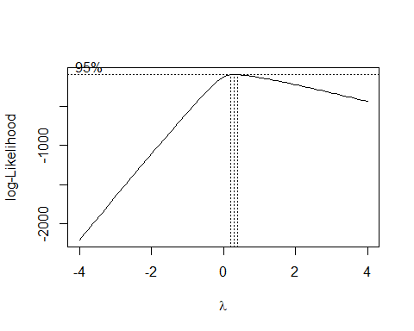

lambda_optimo <- boxcox_result$x[which.max(boxcox_result$y)]  
print(lambda_optimo)

[1] 0.2828283

# Aplica la transformación óptima  
if(abs(lambda_optimo) < 0.01) {  
 insectos$conteo_trans <- log(insectos$Conteo_mod + 1) # +1 para evitar log(0)  
} else {  
 insectos$conteo_trans <- ((insectos$Conteo_mod + 1)^lambda_optimo - 1)/lambda_optimo  
}  
  
# ANOVA sobre datos transformados  
modelo_aov_box <- aov(conteo_trans ~ Tratamiento, data = insectos)  
summary(modelo_aov_box)

Df Sum Sq Mean Sq F value Pr(>F)   
Tratamiento 3 93.75 31.248 4.427 0.0095 **  
Residuals 36 254.14 7.059   
---  
Signif. codes: 0 '***' 0.001 '**' 0.01 '*' 0.05 '.' 0.1 ' ' 1

# Comprobación de supuestos en datos transformados  
shapiro.test(resid(modelo_aov_box)) # Ahora sí hay normalidad

Shapiro-Wilk normality test  
  
data: resid(modelo_aov_box)  
W = 0.96634, p-value = 0.274

leveneTest(conteo_trans ~ Tratamiento, data = insectos) # Hay homogeneidad

Levene's Test for Homogeneity of Variance (center = median)  
 Df F value Pr(>F)  
group 3 0.1369 0.9373  
 36

# ---- Modelos lineales generalizados (GLM) ----  
  
if(!require("DHARMa")){install.packages("DHARMa")}

Cargando paquete requerido: DHARMa

Warning: package 'DHARMa' was built under R version 4.4.3

This is DHARMa 0.4.7. For overview type '?DHARMa'. For recent changes, type news(package = 'DHARMa')

library(DHARMa)  
  
# Fija el nivel de referencia (Control)  
insectos$Tratamiento <- factor(insectos$Tratamiento,  
 levels = c("Control", "A", "B", "A+B"))  
  
# Modelo GLM Gaussiano  
modelo_glm1 <- glm(Conteo ~ Tratamiento, family = gaussian(link = "identity"), data = insectos)  
summary(modelo_glm1)

Call:  
glm(formula = Conteo ~ Tratamiento, family = gaussian(link = "identity"),   
 data = insectos)  
  
Coefficients:  
 Estimate Std. Error t value Pr(>|t|)   
(Intercept) 66.40 16.63 3.992 0.000309 ***  
TratamientoA -33.50 23.52 -1.424 0.163036   
TratamientoB -2.50 23.52 -0.106 0.915955   
TratamientoA+B -50.80 23.52 -2.159 0.037550 *   
---  
Signif. codes: 0 '***' 0.001 '**' 0.01 '*' 0.05 '.' 0.1 ' ' 1  
  
(Dispersion parameter for gaussian family taken to be 2766.906)  
  
 Null deviance: 117864 on 39 degrees of freedom  
Residual deviance: 99609 on 36 degrees of freedom  
AIC: 436.32  
  
Number of Fisher Scoring iterations: 2

Anova(modelo_glm1)

Analysis of Deviance Table (Type II tests)  
  
Response: Conteo  
 LR Chisq Df Pr(>Chisq)   
Tratamiento 6.5979 3 0.08588 .  
---  
Signif. codes: 0 '***' 0.001 '**' 0.01 '*' 0.05 '.' 0.1 ' ' 1

residuos_simulados1 <- simulateResiduals(fittedModel = modelo_glm1)  
plot(residuos_simulados1)

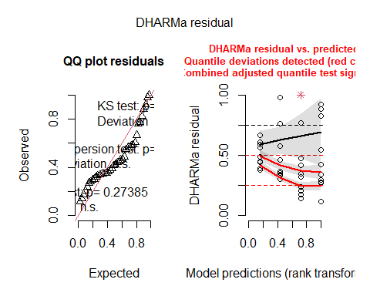

# Modelo GLM Poisson  
modelo_glm2 <- glm(Conteo ~ Tratamiento, family = poisson(link = "log"), data = insectos)  
summary(modelo_glm2)

Call:  
glm(formula = Conteo ~ Tratamiento, family = poisson(link = "log"),   
 data = insectos)  
  
Coefficients:  
 Estimate Std. Error z value Pr(>|z|)   
(Intercept) 4.19570 0.03881 108.116 <2e-16 ***  
TratamientoA -0.70222 0.06742 -10.416 <2e-16 ***  
TratamientoB -0.03838 0.05542 -0.693 0.489   
TratamientoA+B -1.44843 0.08897 -16.279 <2e-16 ***  
---  
Signif. codes: 0 '***' 0.001 '**' 0.01 '*' 0.05 '.' 0.1 ' ' 1  
  
(Dispersion parameter for poisson family taken to be 1)  
  
 Null deviance: 1904.3 on 39 degrees of freedom  
Residual deviance: 1452.2 on 36 degrees of freedom  
AIC: 1657.6  
  
Number of Fisher Scoring iterations: 5

Anova(modelo_glm2)

Analysis of Deviance Table (Type II tests)  
  
Response: Conteo  
 LR Chisq Df Pr(>Chisq)   
Tratamiento 452.09 3 < 2.2e-16 ***  
---  
Signif. codes: 0 '***' 0.001 '**' 0.01 '*' 0.05 '.' 0.1 ' ' 1

residuos_simulados2 <- simulateResiduals(fittedModel = modelo_glm2)  
plot(residuos_simulados2)

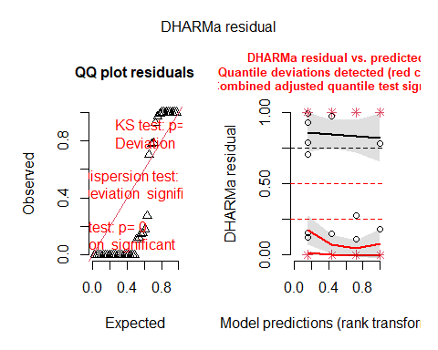

# Modelo Binomial Negativo  
modelo_glmnb <- glm.nb(Conteo ~ Tratamiento, data = insectos)  
summary(modelo_glmnb)

Call:  
glm.nb(formula = Conteo ~ Tratamiento, data = insectos, init.theta = 1.166866553,   
 link = log)  
  
Coefficients:  
 Estimate Std. Error z value Pr(>|z|)   
(Intercept) 4.19570 0.29531 14.208 < 2e-16 ***  
TratamientoA -0.70222 0.41946 -1.674 0.094106 .   
TratamientoB -0.03838 0.41770 -0.092 0.926794   
TratamientoA+B -1.44843 0.42346 -3.420 0.000625 ***  
---  
Signif. codes: 0 '***' 0.001 '**' 0.01 '*' 0.05 '.' 0.1 ' ' 1  
  
(Dispersion parameter for Negative Binomial(1.1669) family taken to be 1)  
  
 Null deviance: 60.235 on 39 degrees of freedom  
Residual deviance: 46.558 on 36 degrees of freedom  
AIC: 382.64  
  
Number of Fisher Scoring iterations: 1  
  
 Theta: 1.167   
 Std. Err.: 0.258   
  
 2 x log-likelihood: -372.636

Anova(modelo_glmnb)

Analysis of Deviance Table (Type II tests)  
  
Response: Conteo  
 LR Chisq Df Pr(>Chisq)   
Tratamiento 13.677 3 0.00338 **  
---  
Signif. codes: 0 '***' 0.001 '**' 0.01 '*' 0.05 '.' 0.1 ' ' 1

residuos_simulados3 <- simulateResiduals(fittedModel = modelo_glmnb)  
plot(residuos_simulados3)

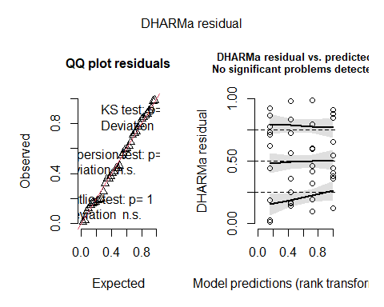

# Este modelo suele ajustarse mejor en recuentos con sobredispersión  
  
# ---- Modelo beta para proporciones ----  
if(!require("betareg")){install.packages("betareg")}

Cargando paquete requerido: betareg

Warning: package 'betareg' was built under R version 4.4.3

if(!require("statmod")){install.packages("statmod")}

Cargando paquete requerido: statmod

Warning: package 'statmod' was built under R version 4.4.3

library(betareg)  
library(statmod)  
  
# Escala el conteo al rango (0, 1)  
insectos$conteo_esc <- (insectos$Conteo - min(insectos$Conteo)) / (max(insectos$Conteo) - min(insectos$Conteo))  
# Ajusta valores extremos  
epsilon <- 1e-4  
insectos$conteo_esc[insectos$conteo_esc == 0] <- epsilon  
insectos$conteo_esc[insectos$conteo_esc == 1] <- 1 - epsilon  
  
modelo_glmbeta <- betareg(conteo_esc ~ Tratamiento, data = insectos)  
summary(modelo_glmbeta)

Call:  
betareg(formula = conteo_esc ~ Tratamiento, data = insectos)  
  
Quantile residuals:  
 Min 1Q Median 3Q Max   
-1.3696 -0.6081 -0.3076 0.1772 4.6053   
  
Coefficients (mean model with logit link):  
 Estimate Std. Error z value Pr(>|z|)   
(Intercept) -0.8666 0.3530 -2.455 0.0141 *  
TratamientoA -0.5364 0.4876 -1.100 0.2713   
TratamientoB 0.2625 0.4862 0.540 0.5892   
TratamientoA+B -1.0254 0.4893 -2.096 0.0361 *  
  
Phi coefficients (precision model with identity link):  
 Estimate Std. Error z value Pr(>|z|)   
(phi) 2.1421 0.4648 4.609 4.05e-06 ***  
---  
Signif. codes: 0 '***' 0.001 '**' 0.01 '*' 0.05 '.' 0.1 ' ' 1   
  
Type of estimator: ML (maximum likelihood)  
Log-likelihood: 32.14 on 5 Df  
Pseudo R-squared: 0.2074  
Number of iterations: 14 (BFGS) + 2 (Fisher scoring)

Anova(modelo_glmbeta)

Warning in printHypothesis(L, rhs, names(b)): one or more coefficients in the hypothesis include  
 arithmetic operators in their names;  
 the printed representation of the hypothesis will be omitted

Analysis of Deviance Table (Type II tests)  
  
Response: conteo_esc  
 Df Chisq Pr(>Chisq)   
Tratamiento 3 8.0406 0.04518 *  
---  
Signif. codes: 0 '***' 0.001 '**' 0.01 '*' 0.05 '.' 0.1 ' ' 1

residuos <- residuals(modelo_glmbeta, type = "pearson")  
plot(residuos)

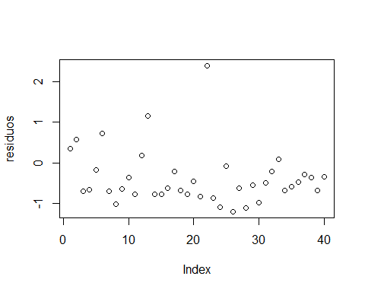

plot(fitted(modelo_glmbeta), residuos)  
abline(h = 0, col = "red")

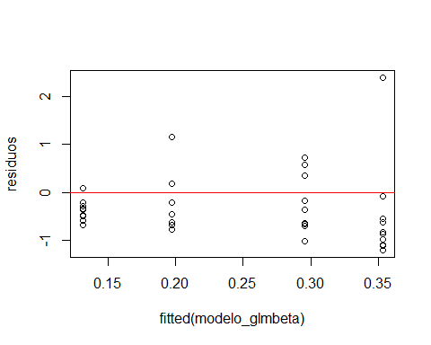

# ---- GLM Gamma ----  
modelo_glm4 <- glm(Conteo_mod ~ Tratamiento, family = Gamma(link = "log"), data = insectos)  
summary(modelo_glm4)

Call:  
glm(formula = Conteo_mod ~ Tratamiento, family = Gamma(link = "log"),   
 data = insectos)  
  
Coefficients:  
 Estimate Std. Error t value Pr(>|t|)   
(Intercept) 4.19570 0.33449 12.543 1.05e-14 ***  
TratamientoA -0.70222 0.47305 -1.484 0.14639   
TratamientoB -0.03838 0.47305 -0.081 0.93579   
TratamientoA+B -1.44843 0.47305 -3.062 0.00414 **   
---  
Signif. codes: 0 '***' 0.001 '**' 0.01 '*' 0.05 '.' 0.1 ' ' 1  
  
(Dispersion parameter for Gamma family taken to be 1.118864)  
  
 Null deviance: 95.597 on 39 degrees of freedom  
Residual deviance: 83.474 on 36 degrees of freedom  
AIC: 374.08  
  
Number of Fisher Scoring iterations: 19

residuos_simulados4 <- simulateResiduals(fittedModel = modelo_glm4)  
plot(residuos_simulados4)

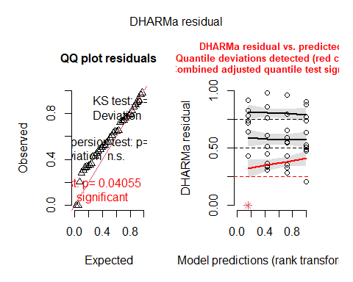

# ---- Detección de distribución: Cullen & Frey ----  
if(!require("fitdistrplus")){install.packages("fitdistrplus")}

Cargando paquete requerido: fitdistrplus

Warning: package 'fitdistrplus' was built under R version 4.4.3

Cargando paquete requerido: survival

library(fitdistrplus)  
descdist(insectos$Conteo, boot = 1000)

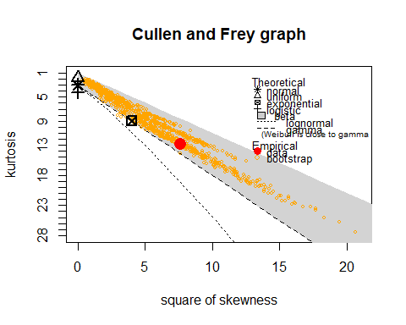

summary statistics  
------  
min: 0 max: 292   
median: 26.5   
mean: 44.7   
estimated sd: 54.97421   
estimated skewness: 2.766358   
estimated kurtosis: 12.8552

# ---- Comparaciones post-hoc (Tukey) para binomial negativa ----  
if(!require("multcomp")){install.packages("multcomp")}

Cargando paquete requerido: multcomp

Cargando paquete requerido: mvtnorm

Cargando paquete requerido: TH.data

Adjuntando el paquete: 'TH.data'

The following object is masked from 'package:MASS':  
  
 geyser

library(multcomp)  
posthoc <- glht(modelo_glmnb, linfct = mcp(Tratamiento = "Tukey"))  
summary(posthoc)

Simultaneous Tests for General Linear Hypotheses  
  
Multiple Comparisons of Means: Tukey Contrasts  
  
  
Fit: glm.nb(formula = Conteo ~ Tratamiento, data = insectos, init.theta = 1.166866553,   
 link = log)  
  
Linear Hypotheses:  
 Estimate Std. Error z value Pr(>|z|)   
A - Control == 0 -0.70222 0.41946 -1.674 0.33741   
B - Control == 0 -0.03838 0.41770 -0.092 0.99972   
A+B - Control == 0 -1.44843 0.42346 -3.420 0.00345 **  
B - A == 0 0.66385 0.41953 1.582 0.38864   
A+B - A == 0 -0.74620 0.42526 -1.755 0.29546   
A+B - B == 0 -1.41005 0.42353 -3.329 0.00447 **  
---  
Signif. codes: 0 '***' 0.001 '**' 0.01 '*' 0.05 '.' 0.1 ' ' 1  
(Adjusted p values reported -- single-step method)

plot(posthoc)

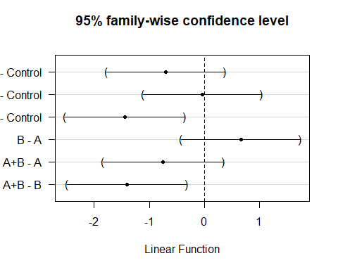

# ---- Comparaciones con emmeans (Tukey) ----  
if (!require("emmeans")) install.packages("emmeans")

Cargando paquete requerido: emmeans

library(emmeans)  
  
emmeans_trat <- emmeans(modelo_glmnb, ~ Tratamiento)  
emmeans_trat

Tratamiento emmean SE df asymp.LCL asymp.UCL  
 Control 4.20 0.295 Inf 3.62 4.77  
 A 3.49 0.298 Inf 2.91 4.08  
 B 4.16 0.295 Inf 3.58 4.74  
 A+B 2.75 0.303 Inf 2.15 3.34  
  
Results are given on the log (not the response) scale.   
Confidence level used: 0.95

comparaciones <- pairs(emmeans_trat, adjust = "tukey")  
comparaciones

contrast estimate SE df z.ratio p.value  
 Control - A 0.7022 0.419 Inf 1.674 0.3374  
 Control - B 0.0384 0.418 Inf 0.092 0.9997  
 Control - (A+B) 1.4484 0.423 Inf 3.420 0.0035  
 A - B -0.6638 0.420 Inf -1.582 0.3887  
 A - (A+B) 0.7462 0.425 Inf 1.755 0.2955  
 B - (A+B) 1.4100 0.424 Inf 3.329 0.0048  
  
Results are given on the log (not the response) scale.   
P value adjustment: tukey method for comparing a family of 4 estimates

if (!require("multcompView")) install.packages("multcompView")

Cargando paquete requerido: multcompView

Warning: package 'multcompView' was built under R version 4.4.3

library(multcompView)  
cld(emmeans_trat, Letters = letters, adjust = "tukey") #Muestra las letras para las medias

Note: adjust = "tukey" was changed to "sidak"  
because "tukey" is only appropriate for one set of pairwise comparisons

Tratamiento emmean SE df asymp.LCL asymp.UCL .group  
 A+B 2.75 0.303 Inf 1.99 3.50 a   
 A 3.49 0.298 Inf 2.75 4.24 ab   
 B 4.16 0.295 Inf 3.42 4.89 b   
 Control 4.20 0.295 Inf 3.46 4.93 b   
  
Results are given on the log (not the response) scale.   
Confidence level used: 0.95   
Conf-level adjustment: sidak method for 4 estimates   
P value adjustment: tukey method for comparing a family of 4 estimates   
significance level used: alpha = 0.05   
NOTE: If two or more means share the same grouping symbol,  
 then we cannot show them to be different.  
 But we also did not show them to be the same.

# ---- Gráfico de boxplot con letras ----  
if(!require("ggplot2")){install.packages("ggplot2")}

Cargando paquete requerido: ggplot2

Warning: package 'ggplot2' was built under R version 4.4.3

pos_letras <- data.frame(  
 Tratamiento = factor(c("A+B", "A", "B", "Control"), levels = c("Control", "A", "B", "A+B")),  
 ypos = c(280, 290, 300, 310), # Ajusta para evitar solapamientos  
 Letters = c("a", "ab", "b", "b")  
)  
  
ggplot(insectos, aes(x = Tratamiento, y = Conteo, fill = Tratamiento)) +  
 geom_boxplot(color = "black") +  
 scale_y_continuous(limits = c(0, 320)) +  
 scale_x_discrete(labels = c(  
 "Control", "A", "B", "A+B")  
 ) +  
 scale_fill_manual(values = c(  
 "#A6CEE3", "#1F78B4", "#B2DF8A", "#33A02C"  
 )) +  
 labs(  
 title = "Boxplot CONTEO",  
 x = expression("Tratamiento"),  
 y = "Conteo (uds.)"  
 ) +  
 geom_text(data = pos_letras, aes(x = Tratamiento, y = ypos-120, label = Letters), size = 5) +  
 theme_minimal() +  
 theme(legend.position = "none")

